**30-05-2025**

**WEB API**

**🌐 What is a Web API?**

A **Web API** (Web Application Programming Interface) is like a bridge that allows different software applications to communicate with each other over the internet. It defines a set of rules and protocols for how software components should interact.

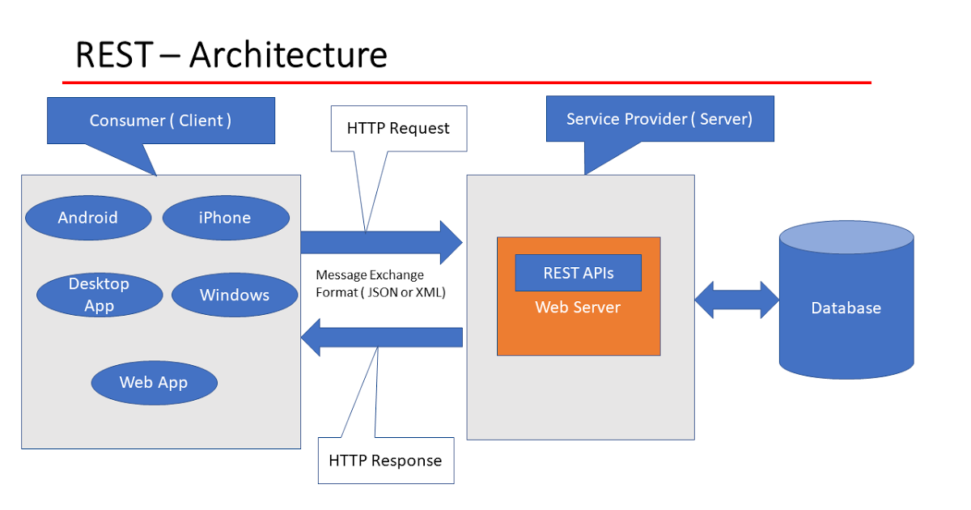

**🧱 What Are the Three Layers?**

In software development, especially when building Web APIs, applications are often structured into three distinct layers to promote organization, scalability, and maintainability. These layers are:

1. **Presentation Layer (User Interface):**
   * This is the topmost layer where users interact with the application.
   * It handles user inputs and displays information.
   * In the context of Web APIs, this could be a web page, mobile app, or any client application that consumes the API.
2. **Business Logic Layer (Application Layer):**
   * This middle layer processes the data received from the presentation layer.
   * It contains the core functionality and rules of the application.
   * For example, it determines what data to retrieve or how to process user requests.
3. **Data Access Layer (Database Layer):**
   * This bottom layer manages the storage and retrieval of data.
   * It interacts directly with the database or data source.
   * It ensures that the business logic layer doesn't need to know the details of data storage.

**🔑 Key Components of a Web API**

1. **Endpoint (URL)**: The specific address where the API can be accessed. For example, <https://api.weather.com/v1/current>.
2. **HTTP Methods**:
   * **GET**: Retrieve data from the server.
   * **POST**: Send new data to the server.
   * **PUT**: Update existing data on the server.
   * **DELETE**: Remove data from the server.
3. **Headers**: Provide metadata, such as authentication tokens or content types.
4. **Request Body**: Contains data sent to the API (e.g., user information when creating an account).
5. **Response**: The API’s reply, usually in JSON or XML format, with the requested data or error messages.

**📦 Real-World Examples of Web APIs**

* **Weather Applications**: Apps like Weather.com use APIs to fetch real-time weather data from servers.
* **Social Media Integration**: Websites use APIs to allow users to log in using their Facebook or Google accounts.
* **Payment Gateways**: E-commerce sites integrate APIs from services like PayPal or Stripe to process payments.
* **Travel Booking**: Platforms aggregate data from various airlines and hotels using APIs to provide comprehensive booking options.

**🔐 Security and Authentication**

Web APIs often handle sensitive data, making security crucial. Common authentication methods include:

* **API Keys**: Simple tokens passed in by the client to identify the calling program.
* **OAuth 2.0**: An authorization framework that allows third-party applications to obtain limited access to a web service.
* **JWT (JSON Web Tokens)**: Compact tokens that are used to securely transmit information between parties.